Icon legend:

🎬 watch the video

☑ task / perform

Why do I need to be good at following Instructions?

Students should learn how to follow directions so they can learn how to perform skills efficiently. According to Education World, if students don't learn, teachers waste time fixing direction-following issues that could have been used to educate the students.

Objectives:

* Demonstrate how to install python
* Create virtual environment
* Install modules from requirements.txt file
* Run a python program

Requirements:

* Internet
* Python installer
* Files
  + requirements.txt
  + 03_triangle_color.py

🎬01 Install python 3.7

☑ Install python in your computer

☑ Open terminal type python press enter

☑ Type print(“Hello, world”)

☑ Take a screen shot like the figure below save as YourLastname_SS01

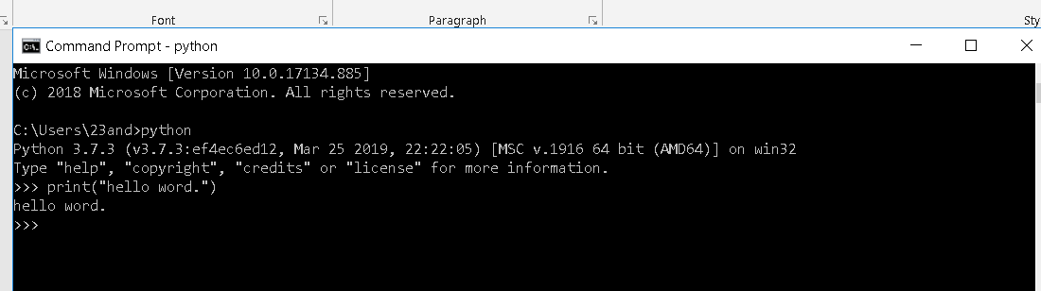

🎬02 Create Virtual Environment

☑ Create your own virtual environment named YourLastnameEnv (example: MartinezEnv)

☑ Activate your virtual environment.

☑ Take a screen shot like the figure below save as YourLastname_SS02

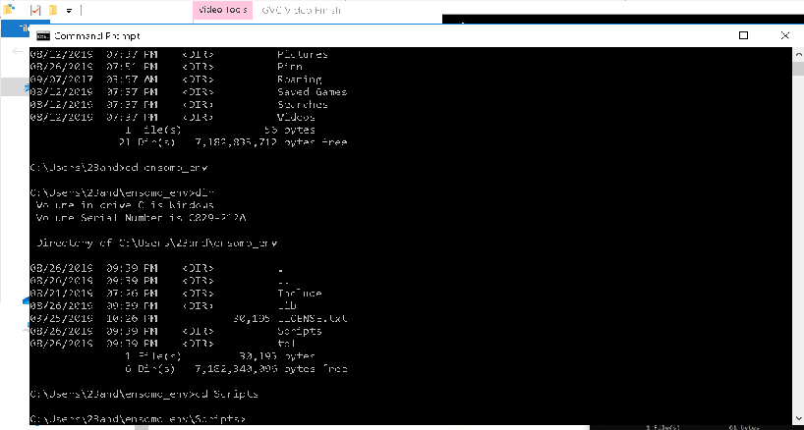

🎬 03 Install modules in requirements.txt

☑ Move requirements.txt file in your virtual environment

☑ Install modules in the file

☑ Type pip freeze

☑ Take a screen shot like the figure below save as YourLastname_SS03

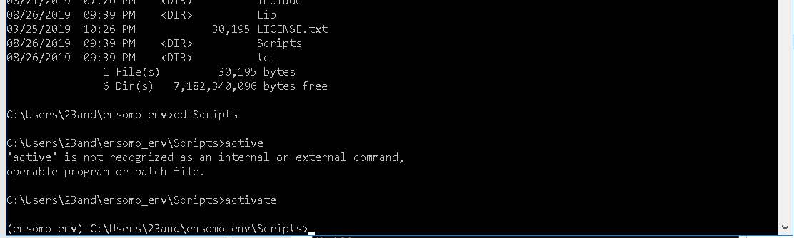

🎬 04 Running program in python

☑ Move 03_triangle_color file in your virtual environment

☑ Run the program

☑ Take a screen shot like the figure below save as YourLastname_SS04

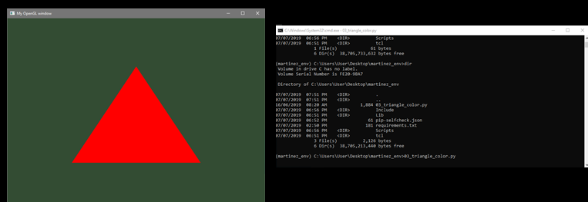

☑ Run the Hi.py program

☑ Take a screen shot save as YourLastname_SS05

References:

<https://uoa-eresearch.github.io/eresearch-cookbook/recipe/2014/11/26/python-virtual-env/>